

**YEAR: 7**

**SUBJECT: SCIENCE**

**TEST: Simple Machines**

**TIME: 35 mins**

**QUESTIONS: Part A: Multiple Choice Questions (10 marks)**

**Part B: Short Answer Questions (18 marks)**

**TOTAL MARKS: 28 marks**

**SECTION ONE: Multiple Choice Questions (1 mark each)**

**Answer this section on the separate multiple choice answer sheet**

1. 1. When using a machine called a force magnifier you apply:

**A** a small force over a large distance

**B** a large force over a large distance

**C** a small force over a small distance

**D** a large force over a small distance

1. 2. The force you need to move an object is called the:

**A** frictional force

**B** effort

**C** load

**D** resistance

3. The chain wheel sprocket on a bike has 60 teeth and the rear wheel sprocket has 15 teeth. The gear ratio for this bike is:

**A** 90

**B** 900

**C** 3

**D** 4

4. Indigenous stone tools were developed by a process called:

**A** striking.

**B** chipping.

**C** cracking.

**D** flaking.

1. 5. What type of simple machine is found on a water bottle cap?

**A** pulley.

**B** wheel and axle.

**C** screw.

**D** lever.

6. An eggbeater can be classed as a:

**A** force magnifier.

**B** speed magnifier.

**C** distance magnifier.

**D** time magnifier.

7. Which of the following uses a wedge as a simple machine?

**A** stairs.

**B** doorknob.

**C** axe.

**D** screw.

1. 8. The mechanical advantage of a lever is given by the formula.
2. Mechanical advantage = $\frac{load}{effort}$

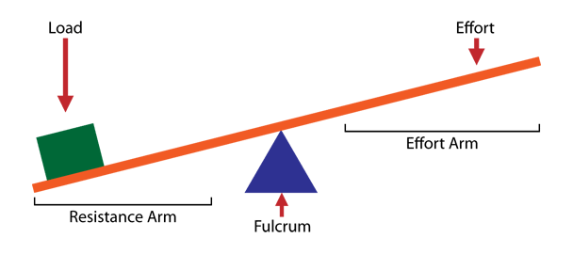

1. The mechanical advantage of a lever with a load of 32kg and 8N effort applied is:

**A** 2

**B** 2.5

**C** 4

**D** 0.4

9. A number of interconnected gears are called a gear train. The force supplied is provided by the driving gear and force is transmitted to the driven gear.

1. 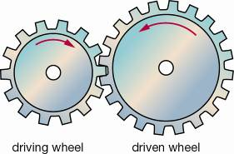
2. Select the correct response for the gears shown in the picture.

**A** The driving wheel rotates faster than the driven wheel.

**B** The driving wheel rotates slower than the driven wheel.

**C** The driving wheel and the driven wheel rotate at the same speed.

**D** The driving wheel and the driven wheel rotate in the same direction.

10. A cable is positioned around a pulley as shown in the diagram below.

1. A 10 kg and a 15 kg mass hang from each end of the cable.
2. 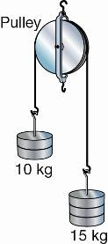
3. Select the correct response:

**A** The two masses are stationary.

**B** The 10 kg mass is moving downwards.

**C** The 15 kg mass is moving upwards.

**D** The 15 kg mass is moving downwards.



**SEMESTER ONE 2017**

**Simple Machines:**

**ANSWER BOOKLET**

**NAME:**

**FORM:** **DATE:**

Multiple Choice Short Answer Total

**/28**

**/18**

**/10**

**SECTION ONE:** Multiple choice answers

Cross (X) through the correct answer.

|  |  |  |  |  |
| --- | --- | --- | --- | --- |
| 1 | a | b | c | d |
| 2 | a | b | c | d |
| 3 | a | b | c | d |
| 4 | a | b | c | d |
| 5 | a | b | c | d |
| 6 | a | b | c | d |
| 7 | a | b | c | d |
| 8 | a | b | c | d |
| 9 | a | b | c | d |
| 10 | a | b | c | d |

**SECTION TWO: Short Answer (18 marks)**

Answer the questions in the spaces provided.

**Question 11**

Below is a picture of a car jack: (3 marks)

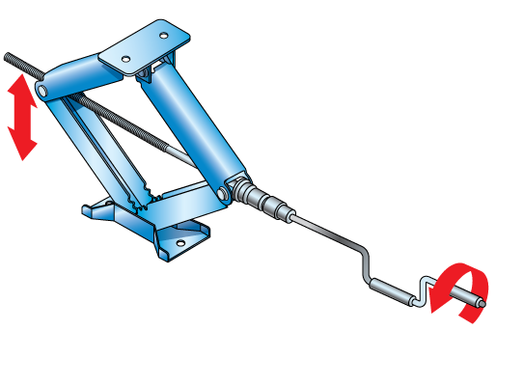

1. Identify whether this car jack is classed as a force magnifier or a speed magnifier:

___________________________________________________________________________

1. Explaining how a person using this machine is able to gain the mechanical advantage required to lift a car.

_________________________________________________________________________________________________________________________________________________________________________________________________________________________________

**Question 12**

1. Identify which three of the following machines are force magnifiers: (3 marks)

wheelbarrow, nutcracker, broom, cricket bat, scissors, tongs, eggbeater ______________________________________________________________________________________________________________________________________________________

**Question 13**

1. Calculate the mechanical advantage of: (2 marks)
2. a machine that requires an effort force of 150 N to lift a 600 N couch.

_________________________________________________________________________________________________________________________________________________________________________________________________________________________________

b) a crowbar that requires a force of 80 N to shift a 240 N rock.

_________________________________________________________________________________________________________________________________________________________________________________________________________________________________

**Question 14**

The three simple machines illustrated here are all types of levers. (6 marks)

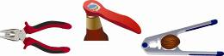

a) On each picture above, draw the position of the fulcrum, effort and load forces in **each** case.

b) Classify each of the above items as first, second or third class levers.

_________________________________________________________________________________________________________________________________________________________________________________________________________________________________

**Question 15**

1. Lily uses three identical pulleys; one in Pulley System A and two in Pulley System B, to lift a 100 N weight. (4 marks)

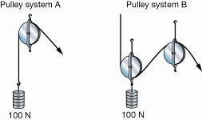

a) Identify which pulley system needs a greater effort force to lift the weight.

______________________________________________________________________________________________________________________________________________________

b) Which pulley system has the greater mechanical advantage?

______________________________________________________________________________________________________________________________________________________

c) Explain how this mechanical advantage is gained.

______________________________________________________________________________________________________________________________________________________

**END OF TEST**

Please go back and check your work / complete any unanswered questions.